Task 1:Working with SNS

SS1: SNS Console

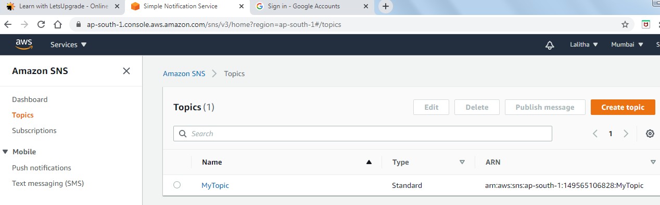

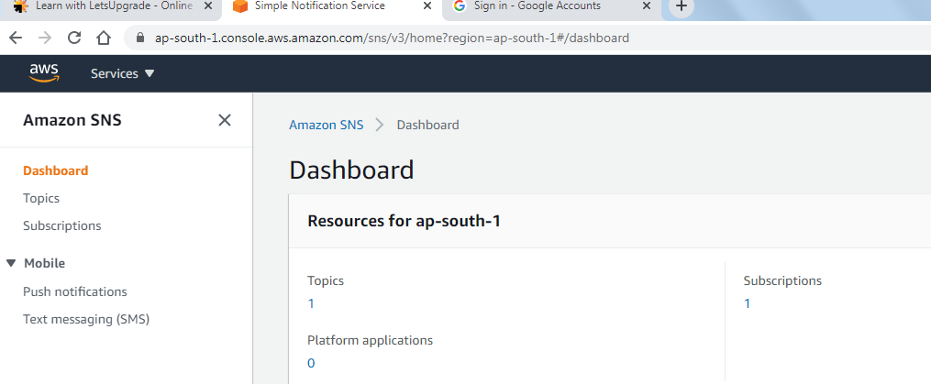

SS2: Our Inbox with published message

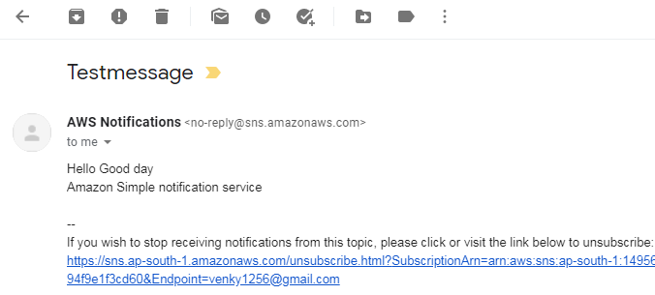

Task 2 :Working with SQS

SS1: SQS Console

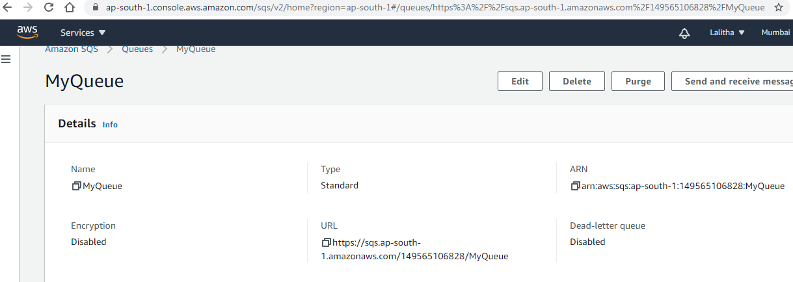

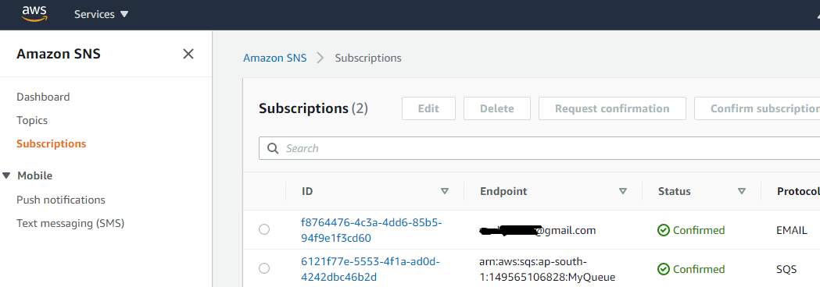

SS: poll for messages and display message window

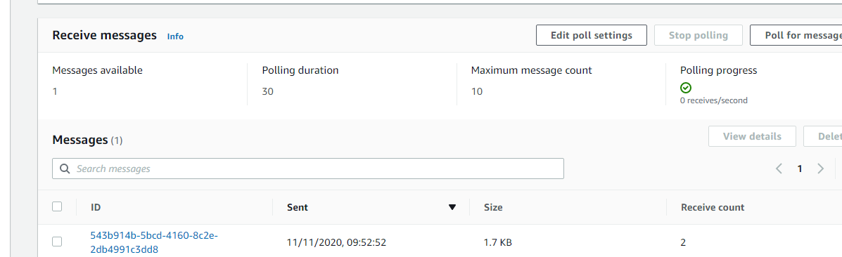

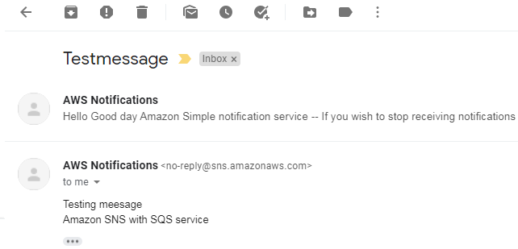

Task3: Working with SES

SS:inbox mail verification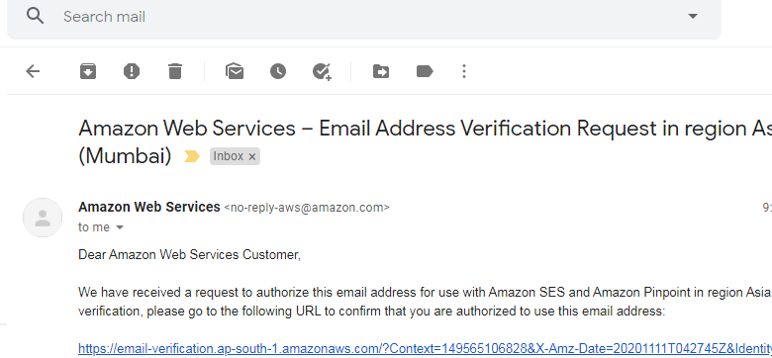

Dynamo DB:  
Task 1:Create a dynamo db table with minimum two disaster recovery zones and verify

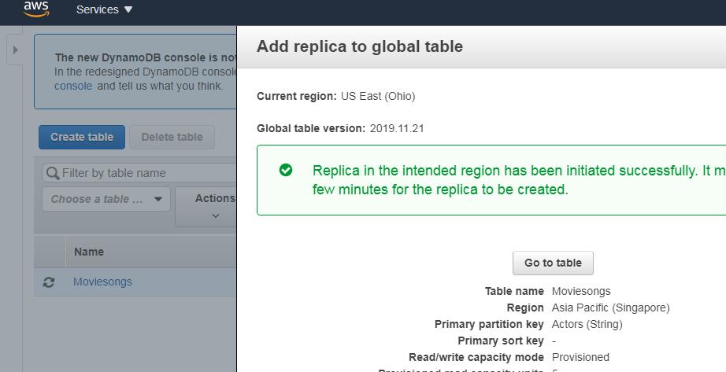

Original Region:

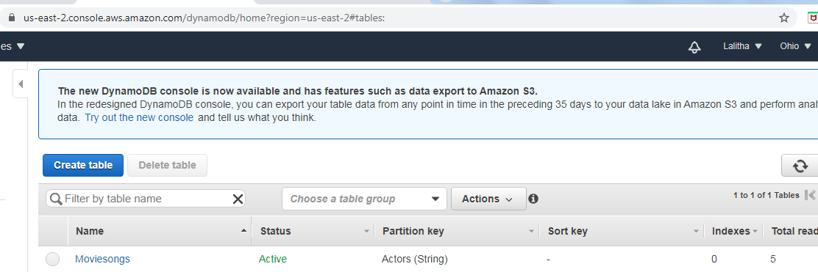

Replica Region:

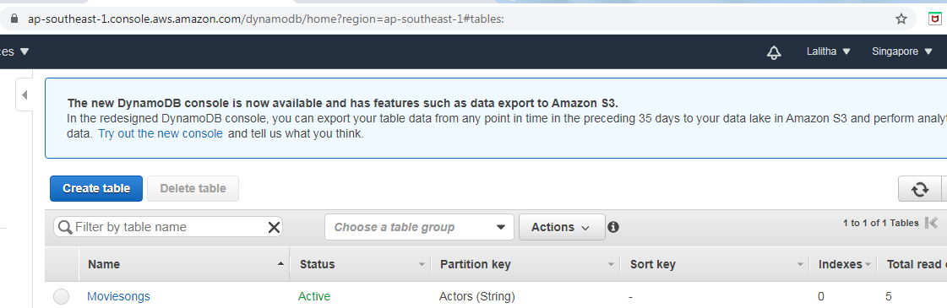

SS: Home region with all items displayed

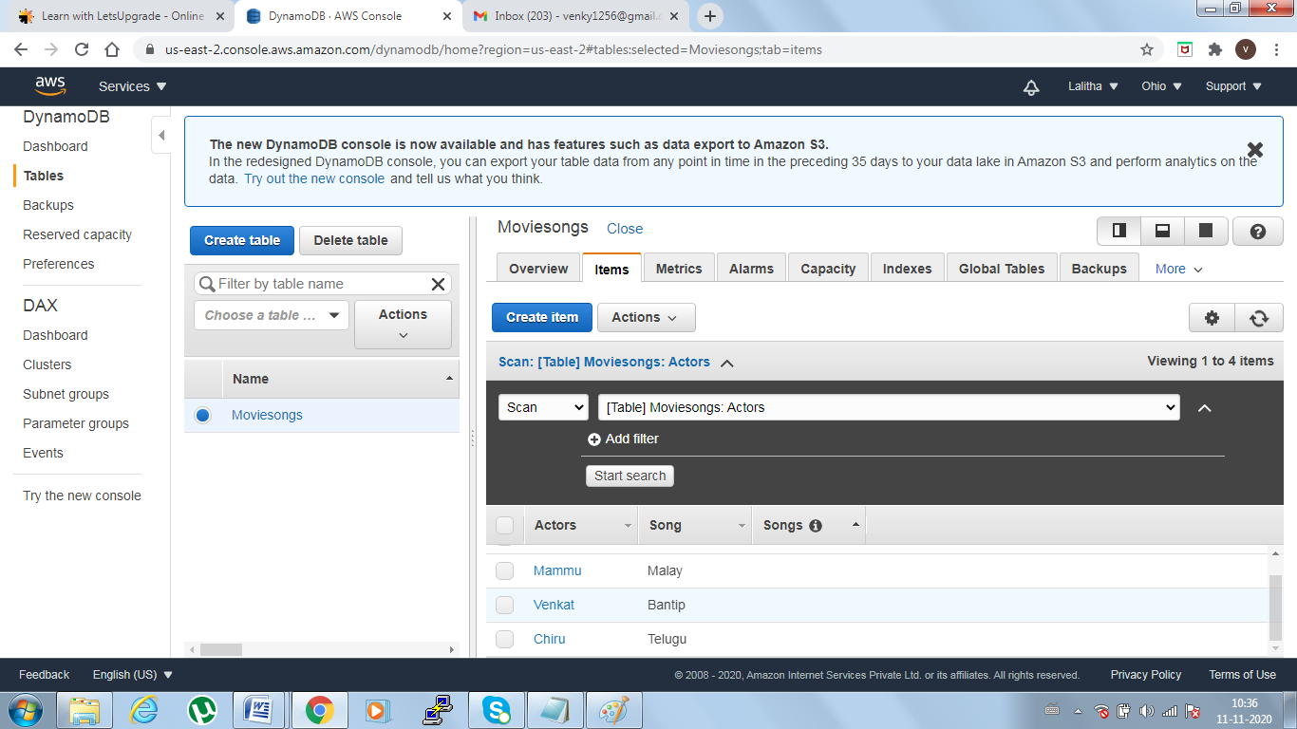

SS: Simple query to fetch itesm

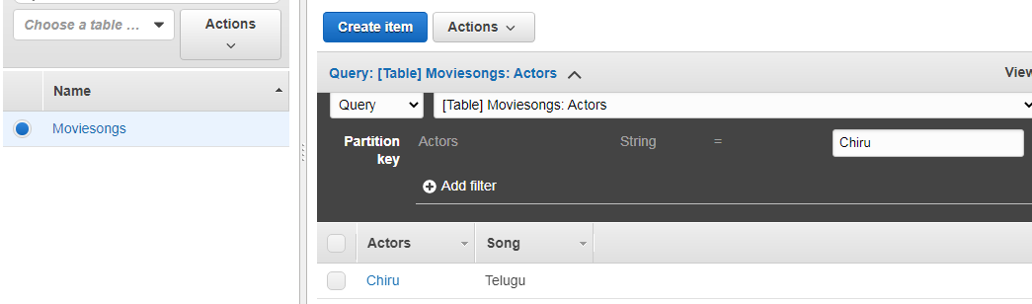

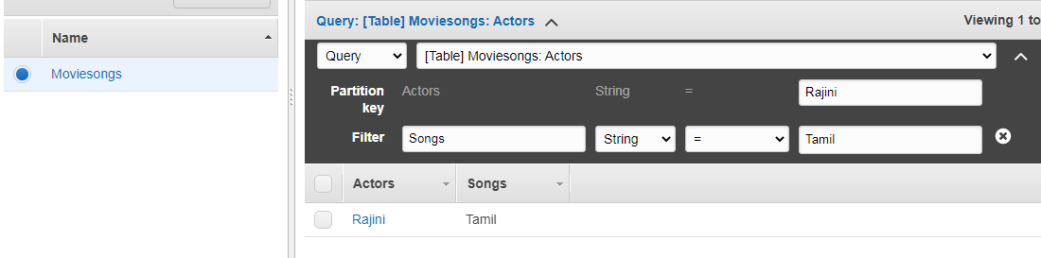

SS: Deletion query and verification

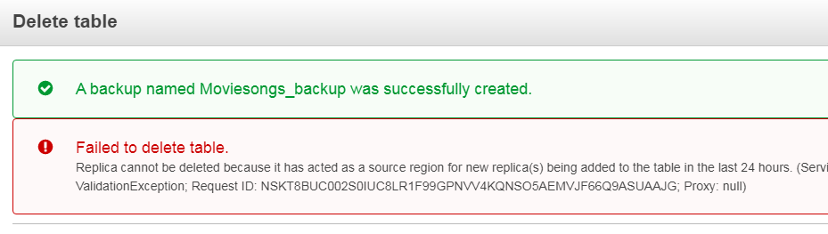

Task 2:Creating a dynamo DB table with global secondary indexes and fetching data using global

SS: Table with items detail

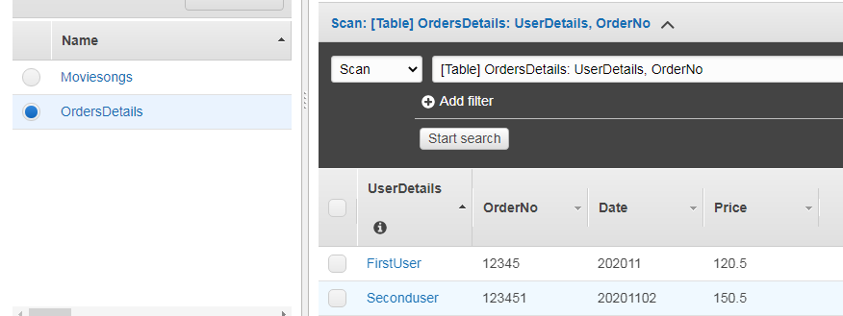

SS: Global index creation

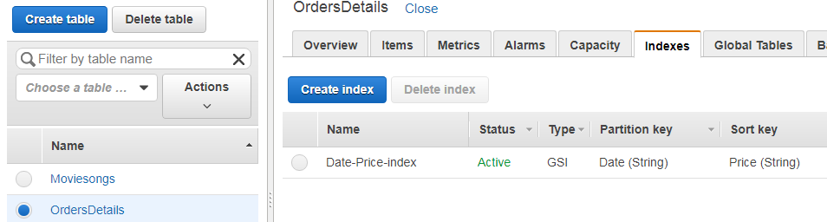

SS: Simple query

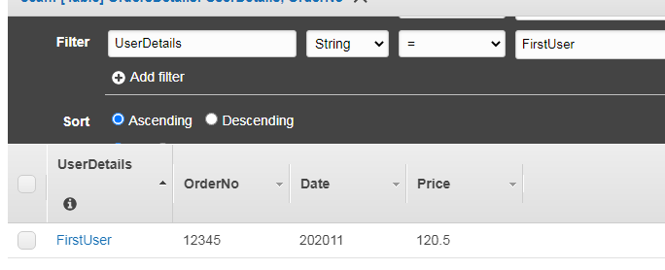

Task 3:Deploying a python application in elastic beanstalk

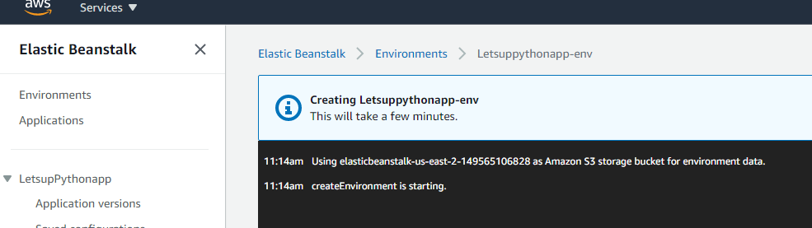

ss1:Application page

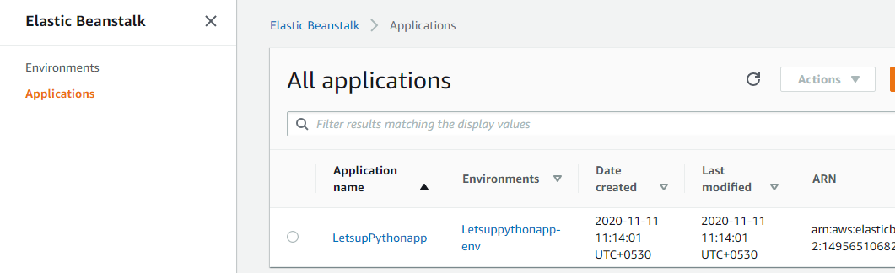

ss2:env list page

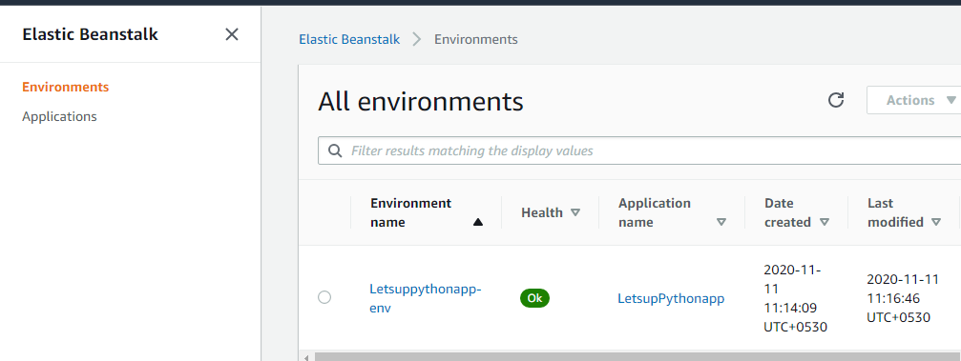

ss3:env health status page

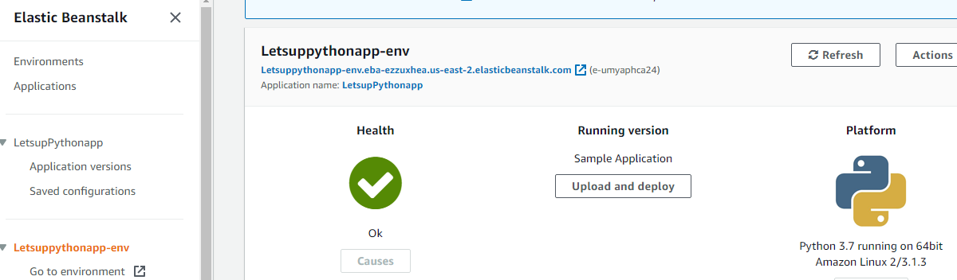

ss4:Web page launched using the elastic beanstalk env

